sudo Command in Linux with Examples

sudo (Super User DO) command in Linux is generally used as a prefix for some commands that only superusers are allowed to run.
If you prefix any command with "sudo", it will run that command with elevated privileges or in other words allow a user with proper permissions to execute a command as another user, such as the superuser.
This is the equivalent of the "run as administrator" option in Windows. The option of sudo lets us have multiple administrators.
These users who can use the sudo command need to have an entry in the sudoers file located at "/etc/sudoers".
To edit or view the sudoers file you have to use the sudo command.
To edit the sudoers file it is recommended to use the "visudo" command.
By default, sudo requires that users authenticate themselves with a password that is the user's password, not the root password itself.

Syntax for sudo command:
sudo -V | -h | -l | -v | -k | -K | -s | [ -H ] [-P ] [-S ] [ -b ]
|
[ -p prompt ] [ -c class|- ] [ -a auth_type ] [-r role ] [-t type
]
[ -u username|#uid ] command

Options Available in the sudo command

Options | Description | Syntax
-V | The -V (version) option causes sudo to print the version number and exit. If the invoking user is already root, the -V option will print out a list of the defaults sudo was compiled with. | sudo | -V
-l | The -l (list) option will print out the commands allowed (and forbidden) the user on the current host. | sudo | -l
-h or --help | The -h (help) option causes sudo to print a usage message and exit. | sudo | -h
-v | If, given the -v (validate) option, sudo will update the user's timestamp, prompting for the user's password if necessary. This extends the sudo timeout for another 5 minutes (or as given in sudoers) but does not run a command. This does not give any output. | sudo | -v
-k | The -k (kill) option to sudo invalidates the user's timestamp. So, the next time sudo is run a password will be required. This option does not require a password and was added to allow a user to | sudo | -k

Options | Description | Syntax
 | revoke sudo permissions from a logout file.
-K | Similar to the -k option, the -K (sure kill) option is used to remove the user's timestamp entirely.  Likewise, this option does not require a password. | sudo -K
-b
 | The -b (background) option tells sudo to run the given command in | sudo -b  [command]
 | the background. Note that if you  use the -b option you cannot use shell job control to manipulate the | (replace "command" with  the command you
 | process. | want run in the background)
-p
 |  | sudo -p
 | the sudo -p prompt command allows you to customize the | "Enter your password"
 | password prompt that sudo | [command]
 | displays when it requests the user's | (replace
 | password. By default, sudo will | "command" with
 | display a generic password prompt | the command you
 | that looks like | want run in the
 |  | background)

Options | Description | Syntax
-n
 | The -n option allows sudo to execute a command without | sudo -n  [command]
 | prompting for a password. This option is useful when running sudo | (replace "command" with
 | commands as background jobs or in  a shell script. The -n option stands for non-interactive. | the command you want run in the background)
-u
sudo -u
[user]
 | The -u option causes sudo to run | [command]
 | the specified command as a user | (replace
 | other than root. To specify a UID | "command" with
 | instead of a username, use #uid. | the command you
 |  | want run in the
 |  | background)
-s
 | The -s option runs the shell specified by the SHELL | sudo -s  [command]  (replace
 | environment variable if it is set or  the shell as specified in the file passwd. | "command" with the command you  want run in the
 |  | background)

Options | Description | Syntax
-H
 | The -H option sets the HOME environment variable to the home | sudo -H  [command]
 | directory of the target user (root by | (replace
 | default) as specified in passwd. By default, sudo does not modify  HOME. | "command" with  the command you want run in the
 |  | background)
-S
 |  | sudo -S
 |  | [command]
 | The -S option causes sudo to read | (replace
 | the password from standard input | "command" with
 | instead of the terminal device. | the command you
 |  | want run in the
 |  | background)
-a
 | The -a option causes sudo to use the specified authentication type  when validating the user, as | sudo -a  [auth-type] [command]
 | allowed by /etc/login.conf. The system administrator may specify a list of sudo-specific authentication | (replace  "command" with the command you
 | methods by adding an "auth-sudo"  entry in /etc/login.conf. | want run in the background)

Options | Description | Syntax
--
sudo --
[command]
 | The -- flag indicates that sudo
 | should stop processing command | (replace
 | line arguments. It is most useful in conjunction with the -s flag. | "command" with  the command you want run in the
 |  | background)

The output of few commands
- -V: The -V (version) option causes sudo to print the version number and exit. If the invoking user is already root, the -V option will print out a list of the defaults sudo was compiled with.

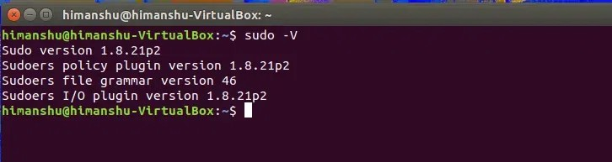
sudo -V
- -l: The -l (list) option will print out the commands allowed (and forbidden) the user on the current host.
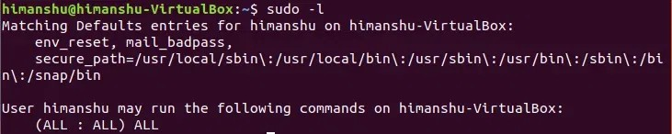
sudo -l

- -h or --help: The -h (help) option causes sudo to print a usage message and exit.
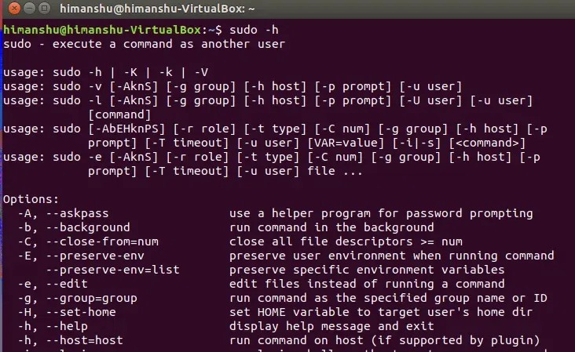

Environment Variables
sudo -h

These environment variables are used by sudo

Tag | Description
EDITOR | Default editor to use in -e (sudoedit) mode if VISUAL is not set
HOME | In -s or -H mode (or if sudo was configured with the  --enable-shell-sets-home option), set to homedir of the target user
PATH | Set to a sane value if the secure_path sudoers option is set.
SHELL | Used to determine shell to run with -s option

Tag | Description
SUDO_PROMPT | Used as the default password prompt
SUDO_COMMAND | Set to the command run by sudo
SUDO_USER | Set to the login of the user who invoked sudo
SUDO_UID | Set to the uid of the user who invoked sudo
SUDO_GID | Set to the gid of the user who invoked sudo
SUDO_PS1 | If set, PS1 will be set to its value
USER | Set to the target user (root unless the -u option is specified)
VISUAL | Default editor to use in -e (sudoedit) mode

In Linux, the sudo command acts like a magic key that unlocks special powers, letting you do important tasks that usually only the superuser can do. It's a way of asking for permission to carry out commands with elevated privileges, like installing software or changing system settings. You use sudo before a command to show you're allowed to run it as the superuser. To use sudo, you usually need to type your own password to prove it's really you doing it, not someone else. By understanding sudo and its options, you can use Linux more effectively and safely.

